MORNING WORSHIP SERVICE
Nov 22, 2015

Opening Song “Count Your Blessings” 644

Opening Prayer/Announcements

Worship Hymns “Blest Be the Tie” 387
“Make Me a Blessing” 569
Special Reading – Pam Daniel “Give Thanks”
“Let’s Just Praise the Lord”

Offering/Offertory

Special Music Colt Nygard

Message Bro. David Atwood
Invitation “Lead Me to Some Soul Today” 560
.

Closing Prayer

Evening Service at 6:00

Living Proof Live
March 4-5, 2016 (Fri & Sat)
Waco, TX: Extraco Event Center
Contact Patti Radford if you might be interested in attending

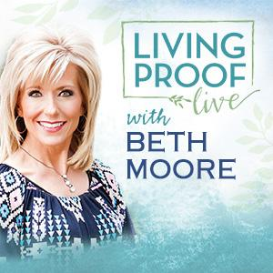
NURSERY – available for children age 0 to Kindergarten
Ashley Smothermon

Hostesses for November Ushers for November
Shirley Marecle, Judie Coffey, Joe Daniel, Mickey Stanford,
Judy Broussard, Otisann McManus David Condron, Hugo Breithaupt

Immediate Need Prayer List
Prayer & Request Information

(Please complete name & address information on reverse side)

I would like to speak with the Pastor.

I would like more information on this church.

I have Prayer Requests or Needs

Date:

Permission to Publicize:
Church Bulletin Yes No
Email Prayer Chain Yes No

Prayer Request:

Prayer For
Name
Address
Phone

Given By
Name
Address
Phone
Please Contact By

Card Phone Visit

Comments

Pray for Helen Emery as she recovers from broken bones

K s b c

Keeping His Word through Sunday School, Bible Study and Church Attendance/Worship

Sunday School Bible Studies for November:

Nov 1st Stand Courageously Daniel 3:13-18,26-28 Nov 8th Live Humbly Daniel 4:28-35 Nov 15th Confront Sin Daniel 5:17-28 Nov 22nd Act Faithfully Daniel 6:6-10,13-16,19-22 Nov 29th When Opposition Strikes Acts 4:23-31

9:45 a.m. each Sunday – A place for everyone

WE’D LOVE FOR YOU TO JOIN US!

